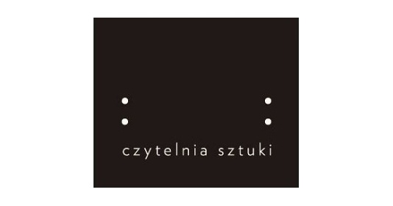

Photographic Workshop with Lorenzo Castore
APPLICATION FORM

NAME
First:
Last:
DATE OF BIRTH

MM / DD / YYYY

E-MAIL

ADDRESS
Street:
Zip code:
City:
Country:

PHONE NUMBER

WWW (optional)

PERSONAL STATEMENT
Please write in English about your photographic experience (max. 900 characters).

PROJECT DESCRIPTION
Please describe in English the idea of your long term project and expectations for this workshop due to the project (max. 900 characters).

SUBMIT YOUR IMAGES
Please send 10 images as samples of your work to: workshop@czytelniasztuki.pl
Files must be in JPEG format and no larger than 500 kb each.

